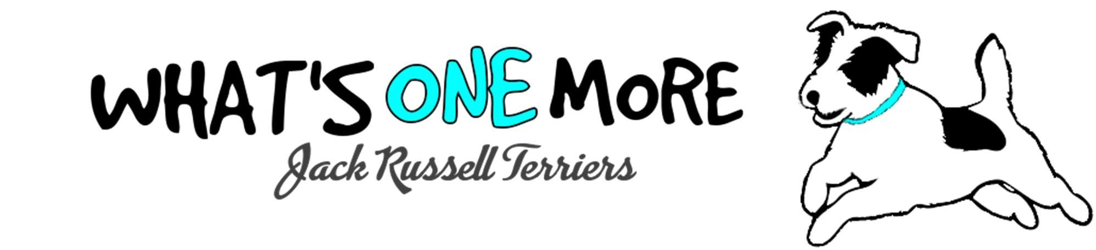

My commitment to you as their breeder is that if anything ever happens in life and you are no longer able to care for one of my puppies, they can always be returned, at any age, or in any state of health.

While we would appreciate full disclosure of the dog’s recent history, I will always take back any dog I have bred. NO QUESTIONS ASKED.
CONTACT INFORMATION
SELLER | BUYER
Vanessa Durand
402 Dillabaugh Road
Kemptville, Ontario K0G 1J0
C: 613 914 5755 H: 613 713 9248
WhatsOneMoreKennel@Gmail.com

YOUR PUPPY
SIRE
DAM
DOB
SEX
Litter Name
Colour
Distinctive Markings
TAIL DOCKED: YES NO
This puppy is sold as Pet Quality
CONTRACT

Your puppy was examined by the veterinarians at Kemptville Animal Hospital on DATE, where they received their first shots and were determined to be in suitable health by a veterinarian to be placed in your home. Documentation attached.
The purchase price of this puppy will be refunded, minus any deposit, if the buyer furnishes the seller with a veterinary certificate indicating that the puppy is unwell or unsound and returned within 72 hours from purchase. The Seller will reimburse no veterinary or shipping costs.
No other warranties or guarantees, expressed or implied, are made under this contract except as stated above.

If you decide to sell/transfer your puppy to another owner, please let WoM know, and pass on my contact information to their new home.

Your puppy’s microchip includes What’s One More’s contact information as a backup/emergency contact for your puppy's safety should they become lost. It is your responsibility to register your puppy’s microchip with your information & keep this up to date.

Our puppies are exposed to other dogs, cats, and kids. We have done our best to teach basic manners and house training, but proper training is the responsibility of their new families.

I will not ask you to spay or neuter your pet, but I do ask that if you choose to breed, you do so responsibly and to perpetuate the true spirit of the Jack Russell Terrier.
This puppy has been sold as pet quality, and as such, no pedigree or registration/recording certificate signature will be provided until proof of spay/neuter is sent to the seller.
If you ever have any questions about your puppy, we are always happy to help, and we encourage you to send photos of your puppy as it grows.
We love to see them!

Congratulations on your
new puppy

